***Ultimate Guide and Roadmap to Learn Machine Learning in 2022!***

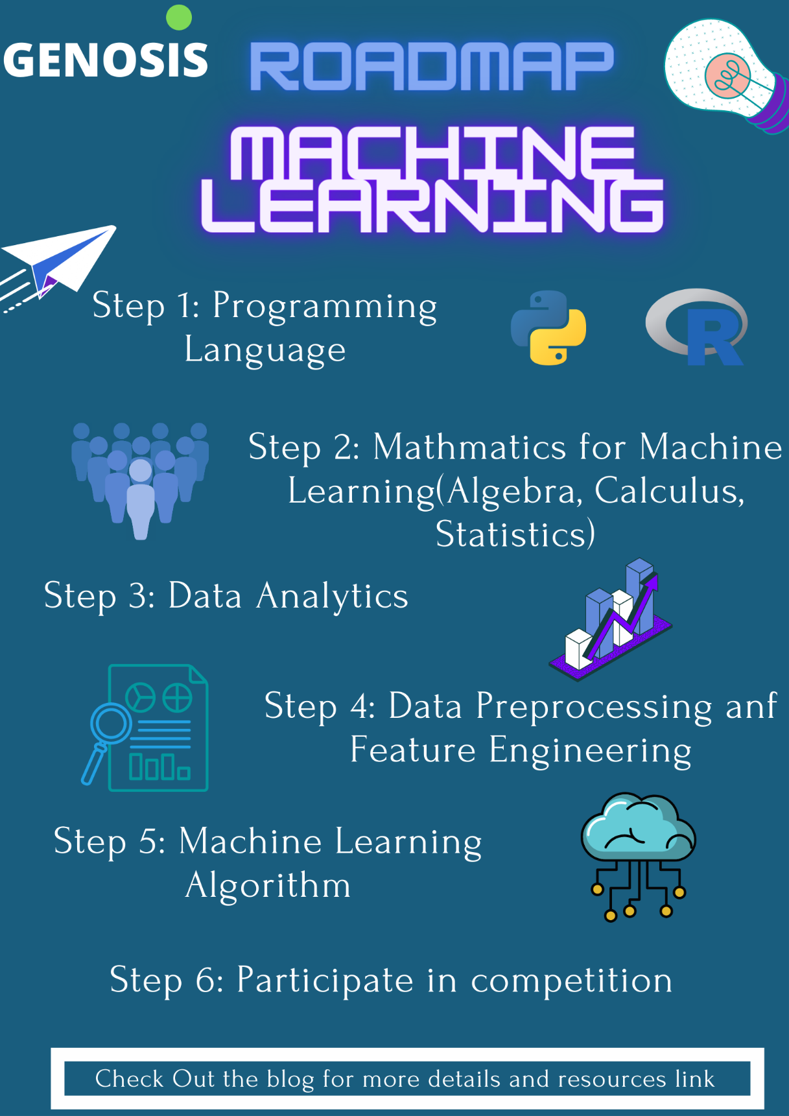

**“Knowledge isn’t free; you have to pay attention.” – Jason Blair**

In this blog, We will talk about the complete machine learning roadmap for beginners. This blog is going to be a bit different. We won’t be telling you about the usual stuff and courses but will be walking you through the realistic events that will happen while you are on your ML journey. The best way to learn the machine learning and checking your progress of learning comes by doing the projects by own.

I am going to share a set of steps that you should take to master Machine learning. The blog contains the proper guide to the journey of the machine learning engineer with the link of resources and some of the best recommendation which we had experienced. Not only the link of the courses but also the place where you can do some hands-on labs so that it would so your progress and make you ready to go on for your own project.

**Step1: Pick a programming language & Get Started!**

The first step to start with machine learning is to pick up a programming language. There are different programming languages in the market, but the most suitable for machine learning are Python and R.

Resources for Python Programming:

* [Crash Course on Python](https://www.coursera.org/learn/python-crash-course) (Coursera)
* [Data Visualization in python](https://www.coursera.org/learn/python-for-data-visualization) (Coursera)

Both the course is necessary to be complete by an individual to start with machine learning.

Resources for R Programming:

[R programming](https://www.coursera.org/learn/r-programming) (Coursera)

After concept there is a need of proficiency in the skill you learnt so best platform to practice is Hackerrank:

[Hackerrank Python](https://www.hackerrank.com/domains/python)

If you want to learn by doing then sololearn is the best platform:

[Python core](https://www.sololearn.com/learning/1073)

[R programming](https://www.sololearn.com/learning/1147)

**Step 2: Learn Linear Algebra**

You should learn Linear Algebra if you wish to master Machine Learning and wanted to become a pro! This is essential because if you want to tune your models with maximum flexibility, you need to know how they work, and knowing linear algebra is a must for that.

Resources:

The best course to learn the linear algebra and multivariable calculus and also to do some exciting hands-on lab were we get to apply the concepts:

* [Mathematics for Machine Learning Specialization](https://www.coursera.org/specializations/mathematics-machine-learning) (Coursera)

Second Resource:

* [Essential Mathematics for machine learning](https://www.youtube.com/playlist?list=PLLy_2iUCG87D1CXFxE-SxCFZUiJzQ3IvE) (Nptel)

**Step 3: Learn Statistics**

Having a basic understanding of probability and statistics is important when it comes to mastering Machine Learning.

Resources:

* [Introduction to Statistics](https://www.coursera.org/learn/stanford-statistics) (Coursera)
* [Statistics for machine learning](https://www.youtube.com/playlist?list=PLZoTAELRMXVMhVyr3Ri9IQ-t5QPBtxzJO) (Youtube)

**Step 4: Data Analytics:**

Learn Numpy

Learn Pandas

The main purpose of doing the data analytics is to know about the dataset that you are going to work with and make the necessary modification or manipulation before starting with the machine learning model.

Resources:

* [Data Analysis using Python](https://www.youtube.com/watch?v=GPVsHOlRBBI) (Youtube)
* [Data Analytics with pandas](https://jovian.ai/learn/data-analysis-with-python-zero-to-pandas) (Jovian)
* [100 Numpy Exercise](https://jovian.ai/aakashns/100-numpy-exercises) (Jovian)

**Step 5: Data Preprocessing and Feature Engineering:**

The most important step in machine learning is to do preprocessing of the data before fitting the data into the machine learning model. The data preprocessing contains the standardization of the data so that it will be ready to put into the machine learning model. The feature engineering contains the selection of the best features in the dataset for enhancing the efficiency of the machine learning model or creating the new best features with the use of information in the dataset.

Free Resources:

[Feature Engineering](https://www.coursera.org/learn/feature-engineering) (Coursera)

Resources:

* [Pre-Processing for machine learning in Python](https://www.datacamp.com/courses/preprocessing-for-machine-learning-in-python#!)
* [Feature Engineering for Machine Learning in Python](https://www.datacamp.com/courses/feature-engineering-for-machine-learning-in-python#!)

**Step 6: Learn Core ML Algorithms**

Once you have some idea of using sklearn after learning python, you should start looking into how these machine learning algorithms work. Logic building is the crucial part so that you would be ready to implement to make the best precision model.

Resources:

The best resource to start with:

* [Machine Learning](https://www.coursera.org/learn/machine-learning) (Coursera)
* [Machine Learning](https://www.youtube.com/watch?v=NWONeJKn6kc) (freecodecamp)
* [Machine Learning Crash Course](https://developers.google.com/machine-learning/crash-course) (Google Developers)
* [Machine Learning](https://www.youtube.com/playlist?list=PLLssT5z_DsK-h9vYZkQkYNWcItqhlRJLN) (Andrew Ng)
* [Machine Learning Course](https://www.youtube.com/playlist?list=PLD63A284B7615313A) (Caltech University)

Our recommendation would be to first start with the Benchmark dataset for the analysis of the data and apply your model. The starting point of your machine learning journey is now, go on with this dataset.

* Iris Dataset
* lfw Dataset
* Wine Dataset

Now it’s time to participate in the competition to test your skill and also learn something new. The platforms to participate in the machine learning competition are:

* Kaggle

The beginner friendly contest that you can participate in to understand about the platform and to apply your learning are Titanic and House Prediction

* Machine Hack
* Open ML
* Hacker Earth

**Step 7: Learn Deployment**

To host your machine learning models with a powerful backend, you will need to learn frameworks like Django and Flask. Docker and Kubernetes can be of great help if you want to ship and deploy your models quickly.

Resources:

[Machine Learning Operations Fundamentals](https://www.coursera.org/learn/mlops-fundamentals)

[Model Deployment using Flask](https://dphi.tech/courses/model-deployment-using-flask)

I hope this post would have a helped you and the genosis will be back on with the roadmap after this stage till then be ready!

From Arpitshivam Pandey And Hrishikesh Yadav